**Trace X** – Line Follower

by

Prateek Baraiya – Team Leader

Harsh Shah – Team Member

Bhavya Thacker – Team Member

Khushi Thakkar – Team Member

Krishna Dave – Team Member

**1. Components Used**:

**1.1 Arduino Uno**

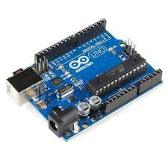

**Specifications**:

* Microcontroller: ATmega328P
* Operating Voltage: 5V
* Input Voltage (recommended): 7-12V
* Digital I/O Pins: 14 (6 PWM)
* Analog Input Pins: 6
* Clock Speed: 16 MHz

**Purpose**:

The Arduino Uno acts as the brain of the line follower, reading sensor inputs and controlling the motors to keep the bot on track.

**1.2 HW - L293D Motor Driver**

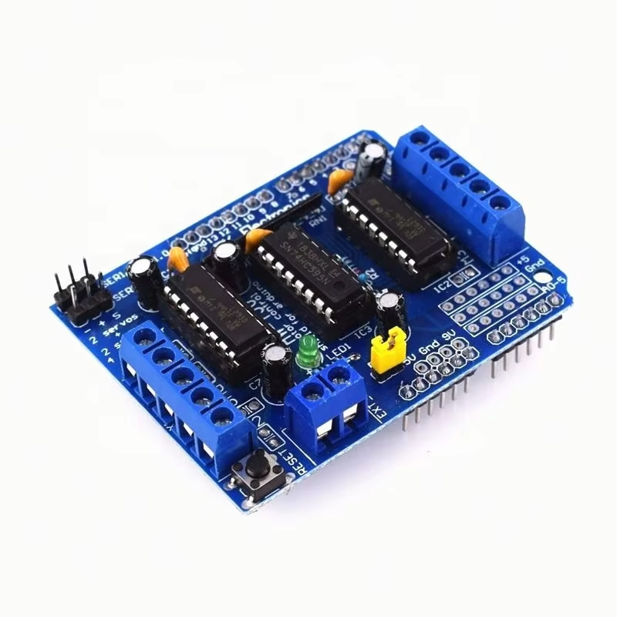

**Specification**:

* Operating Voltage: 4.5V – 36V
* Logic Voltage: 5V
* Max Continuous Current per Channel: 600mA
* Peak Current: 1.2A per channel
* Number of Channels: 2 (can control two DC motors)
* Control Logic: TTL (High = Forward, Low = Reverse)
* PWM Support: Yes, for speed control
* Built-in Diodes for Back EMF Protection

**Purpose**:

The HW-L293D motor driver controls the speed and direction of DC motors using low-power signals from a microcontroller - Arduino. It enables bidirectional motor control, making it ideal for the applications of a line follower.

**1.3 QTR 8RC Reflectance Sensor Array**

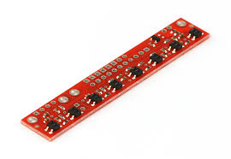

**Specifications**:

* Number of Sensors: 8 infrared LED/phototransistor pairs
* Operating Voltage: 3.3V to 5V
* Output Type: Digital (high/low, based on reflectance)
* Optimal Sensing Range: 3mm to 9mm from the surface
* Sensor Pitch: 9.525mm
* Current Consumption: ~25mA per sensor when active
* Response Time: Typically <1ms for fast line detection

**Purpose**:

The QTR-8RC Reflectance Sensor Array is used for line detection, edge following, and object sensing in robotics. It helps a robot differentiate between dark and light surfaces, making it ideal for applications like line-following robots.

**1.4 N-20 Motor**

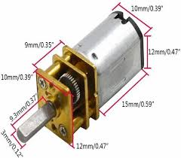

**Specifications**:

* Operating Voltage: 3V – 12V
* No-load Speed: ~30 RPM to 1000+ RPM
* No-load Current: ~30mA – 100mA
* Stall Current**:** ~0.3A – 1.5A
* Torque: 10 – 300 g.cm

**Purpose**:

The motor provides the necessary movement for the robot by driving its wheels. It receives signals from the motor driver, which adjusts speed and direction based on sensor inputs, allowing the robot to follow a predefined path.

**1.5 LM2596 DC-DC Buck Boost Module**

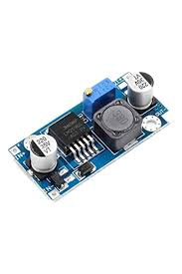

**Specifications**:

* Input Voltage: 3V – 40V DC
* Output Voltage: 1.25V – 35V DC (adjustable)
* Output Current: Up to 3A (with heat sink)
* Efficiency: Up to 92%
* Switching Frequency: 150 kHz
* Load Regulation: ±0.5%
* Voltage Regulation: ±2.5%

**Purpose**:

The LM2596 module is used to efficiently step down (buck) or step up (boost) voltage to provide a stable power supply for electronic circuits. In projects like a line follower robot, it ensures that components like the motor driver and sensors receive a steady voltage, improving performance and reliability.

**1.6 Miscellaneous Components:**

1.6.1 Jumper Wires

1.6.2 Connecting Wires

1.6.3 Switch

1.6.4 BO Wheels (Tyres)

1.6.5 Rechargeable Battery (Cells)

1.6.6 Wooden Chassis Board

2. **Circuit Diagram**:

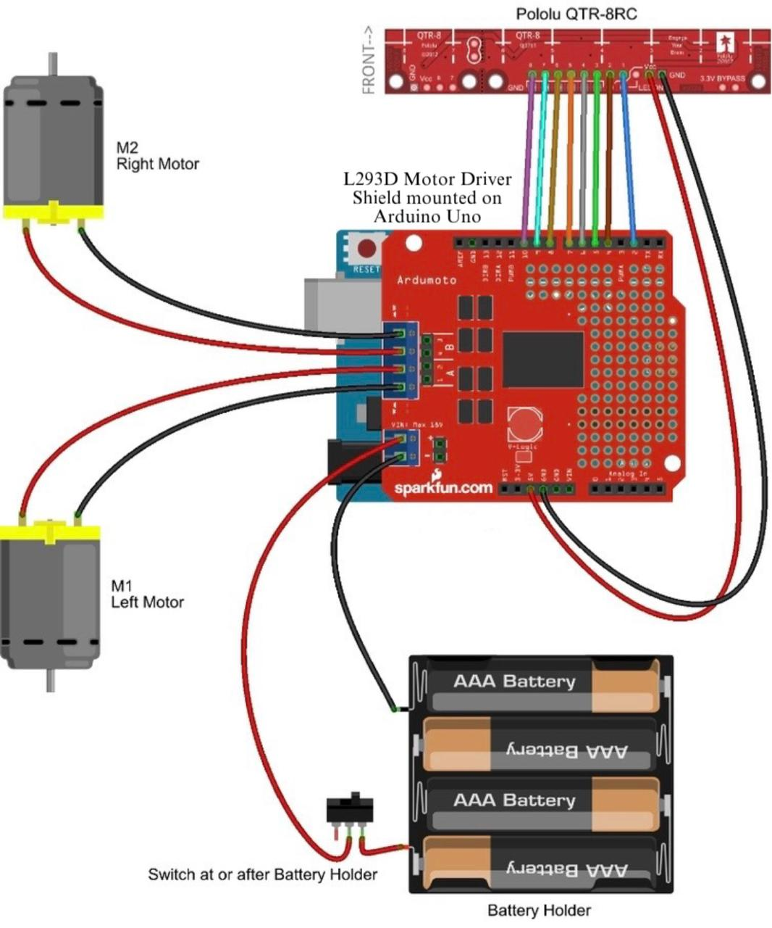

**3. Workflow:**

